**Dee Hsu**

**Actress, Singer and Television Host**



Her maiden name is Hsu Hsi-ti but her stage name is Dee Hsu. She is even better known by the nicknames Xiǎo S or Little S. The nicknames date back to the period when she sang in a duo named ASOS with her sister, Barbie Hsu who was known as Big S. Dee Hsu, a Taiwanese, has done several things in her career. She has been an actress, television host, ballroom dancer and a singer among other things. Dee Hsu is famous for her quick-witted caustic n presenting shows.



She has 1 win and 4 nominations at the Golden Bell Awards, Taiwan to her credit. She won the 2005 Golden Bell Award Best Host for a Variety Show *Kangxi lai le* (2004) which she shared with Kevin Tsai. In 2004 she was nominated for the Best Performance by an Actress in a Supporting Role in a Television Series, *Say Yes Enterprise* (2004). In 2006 and 2008 she won nominations for Best Host for a Variety Show in the same *Kangxi lai le* (2004)



Dee Hsu was born on June 14, 1978 in Taipei, Taiwan. She is married to a wealthy businessman, Mike Hsu. Mike and Dee got married in 2005. The couple have 3 daughters namely Elly who was born on January 16, 2006, Lily, born November 26, 2007 and Alice born April 5. She is a devoted wife and mother. However, in August 2013, her husband, herself and her father-in-law Xu Qing Xiang, were sued. They were accused of being involved in the bread store chain "Pang Da Ren" scandal that rocked the country.

Dee Hsu was deeply troubled by the controversy affecting her family and was reported to have lost weight over the issue when she appeared for the recording of Here Comes Kang Xi. Top Pot Bakery was jointly owned by Dee's husband his father Hsu Ching-hsiang. The company was endorsed by Dee. However, they were accused of false advertising and were summoned for questioning on an insider trading case concerning the Holding company of Top Pot Bakery, Genome International Biomedical Co. Ltd (GIBC).

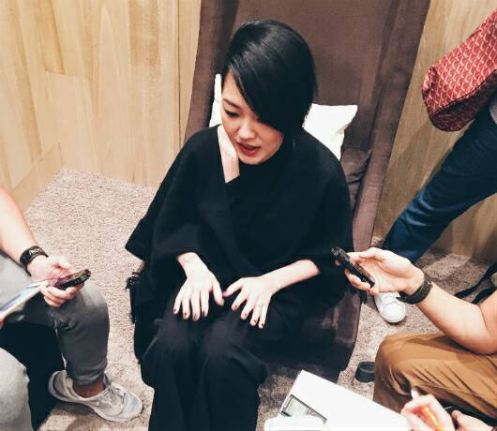

She had also been involved in a legal tussle over a name earlier on n her career in the 90s. Before becoming a television host, Dee sang in a duo with her elder sister, Barbie Hsu. They were originally known as "S.O.S." (Sisters of Shu). Copyright issues soon emerged and they had to change the group's name to A.S.O.S. (All Sisters of Shu), otherwise they would have been sued.

She has since 1999 steadily wound down her singing career in favor of acting and hosting TV programs. She has hosted the highly successful *GUESS* as well as the very popular KangXi *Lai Le* which started hosting in 2004.



In a recent interview with *Her World Dee* Hsu revealed that there was a point in time when she thought she would make it to the top in her career in the entertainment business. She became apprehensive and expected her career to nose dive after the hit show in which she played the star role *Mr. Con and Ms. Csi* ceased. However good fortunes have smiled on her and her career rather than nose diving began a rapid ascent to the top after the show ended. She was overwhelmed with producers proposing her name to host several variety shows. In 2016 she was able to star in a new talk show which she presented several male celebrities from China and Taiwan.

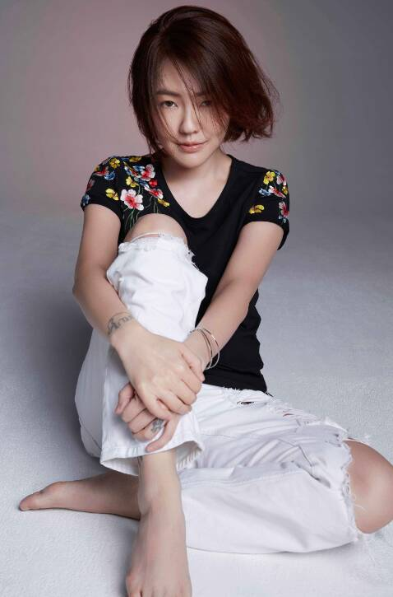

Barbie Hsu the elder sister of Dee Hsu has lent a strong supporting hand to her sister especially over the controversies surrounding the family. Several artistes have also come out in her support saying that Dee and her husband are kind hearted people that have done a lot of charity work for the people. In the meantime Dee and her husband are maintaining a low profile and have reduced their outings and work schedules considerably.